Output for facebook feed:

Developers.facebook.com Account:

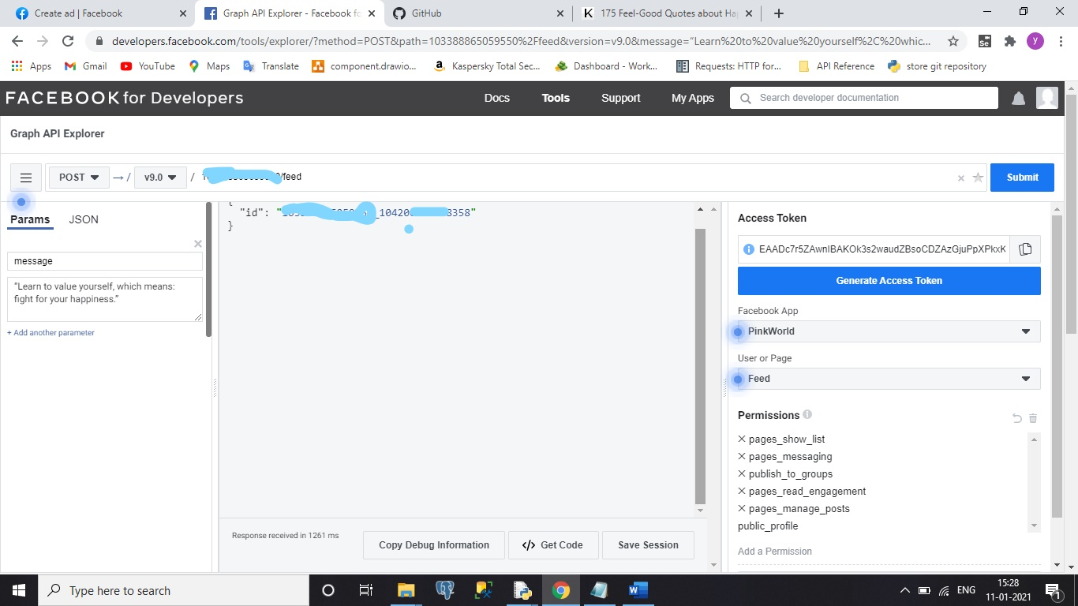

facebook Account:

